**Mini Project - II**

**(2020-2021)**

**Friends & Family Restraunt**

**(F&F)**

**Synopsis**

**Department of Computer Engineering & Applications**

**Institute of Engineering & Technology**



**Submitted To:**

**Submitted By:**

Arvind Jaiswal (181500133)

Umesh Pratap Singh (181500767)

Vipul (181500801)

Satyam Singh (181500629)

Mr. Mandeep Singh

(Assistant Professor)

**Acknowledgement**

It gives us a great sense of pleasure to present the synopsis of the B.Tech Mini-Project-II **(Friends & Family Restraunt)** undertaken during B.Tech IIIrd Year. This project in itself is going to be an acknowledgement to the inspiration, drive and technical assistance will be contributed to it by many individuals.

We owe special debt of gratitude to **Mr. Mandeep Singh ,** Assistant Professor Department of CEA, for providing us with an encouraging platform to develop this project, which thus helped us in shaping our abilities towards a constructive goal and for his constant support and guidance to our work. His sincerity, thoroughness and perseverance is been a constant source of inspiration for us. We believe that he will shower us with all his extensively experienced ideas and insightful comments at different stages of the project & also taught us about the latest industry-oriented technologies.

We also do not like to miss the opportunity to acknowledge the contribution of all faculty members of the department for their kind guidance and co-operation.

Arvind Jaiswal (181500133)

Umesh Pratap Singh (181500767)

Vipul (181500801)

Satyam Singh (181500629)

**Abstract**

Restaurant is a kind of business that serves people all over world with readymade food. Currently this industry is going on with lot of flare. People feel more comfortable with lot of variations in the selection and consumption of their food in their busy life.

One can see lot more restaurant in the world. Even in India one can see thousands of restaurants with dishes from all over the world like from America, Japan, Turkey, etc fulfilling the needs of people with nourishments and enjoyments.

Let’s concentrate on booking area in a restaurant. In traditional booking system, a customer has to make a phone call in order to get his meal reserved. If luckily the phone gets connected, then the customer does some formal conversation like hello, hi, etc. Then he demands for today’s menu and do some discussion over menu items then he orders and he has to give some of this identification specifications. This process takes 5-8 minutes to complete. On the receiver side there is hardly one phone line and one operator. So he can cover around 15-20 orders maximum in an hour.

For each booking he has to register manually on paper and puts the order in a queue with specific priority according to time and quantity, and then a cook is assigned for the specific order to complete it. But our problem lies within domain of end customer and restaurant.

**Objective**

Friends and Family Restraunt is a website designed primarily for use in the food delivery industry. This system will allow hotels and restaurants to increase scope of business by reducing the labor cost involved. The system also allows to quickly and easily manage an online menu which customers can browse and use to place orders with just few clicks. Restaurant employees then use these orders through an easy to navigate graphical interface for efficient processing.

**Expected Design**

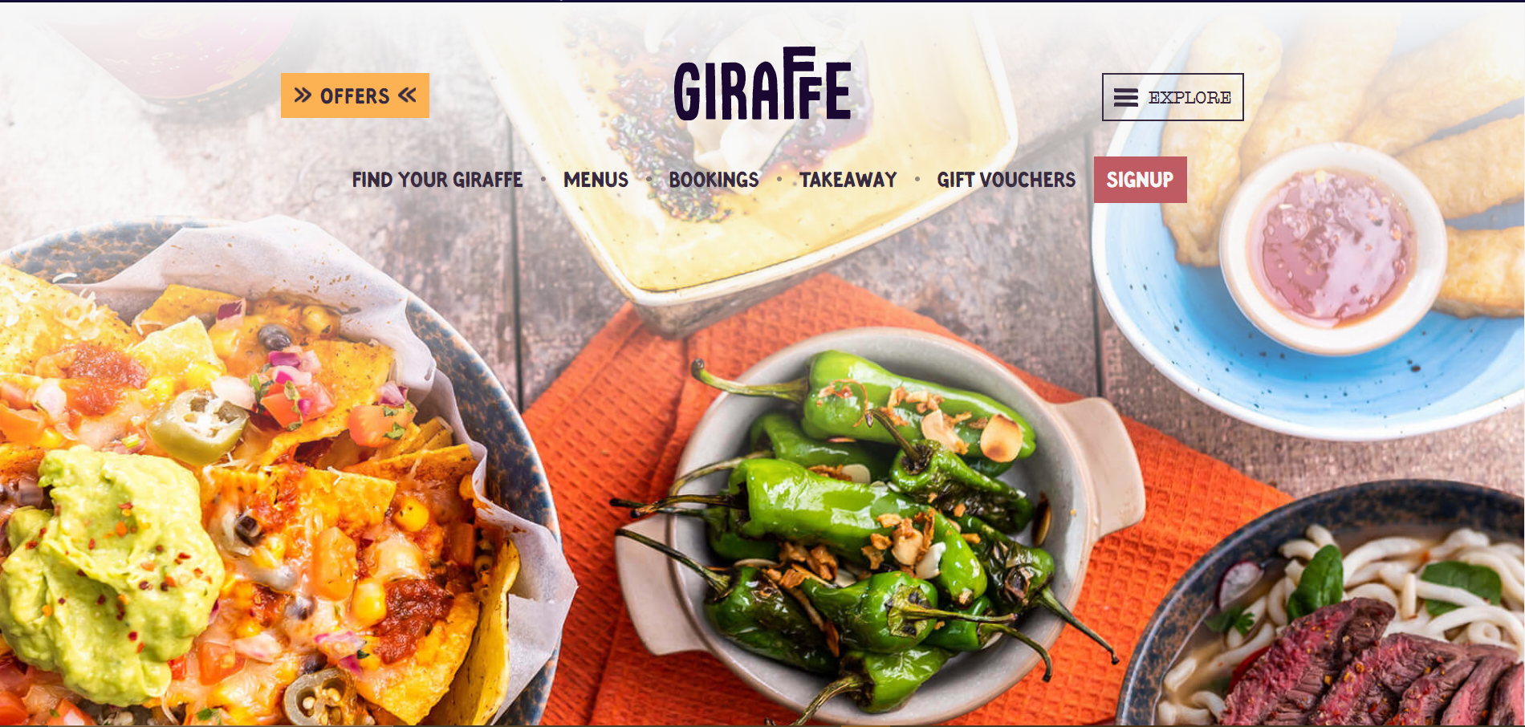

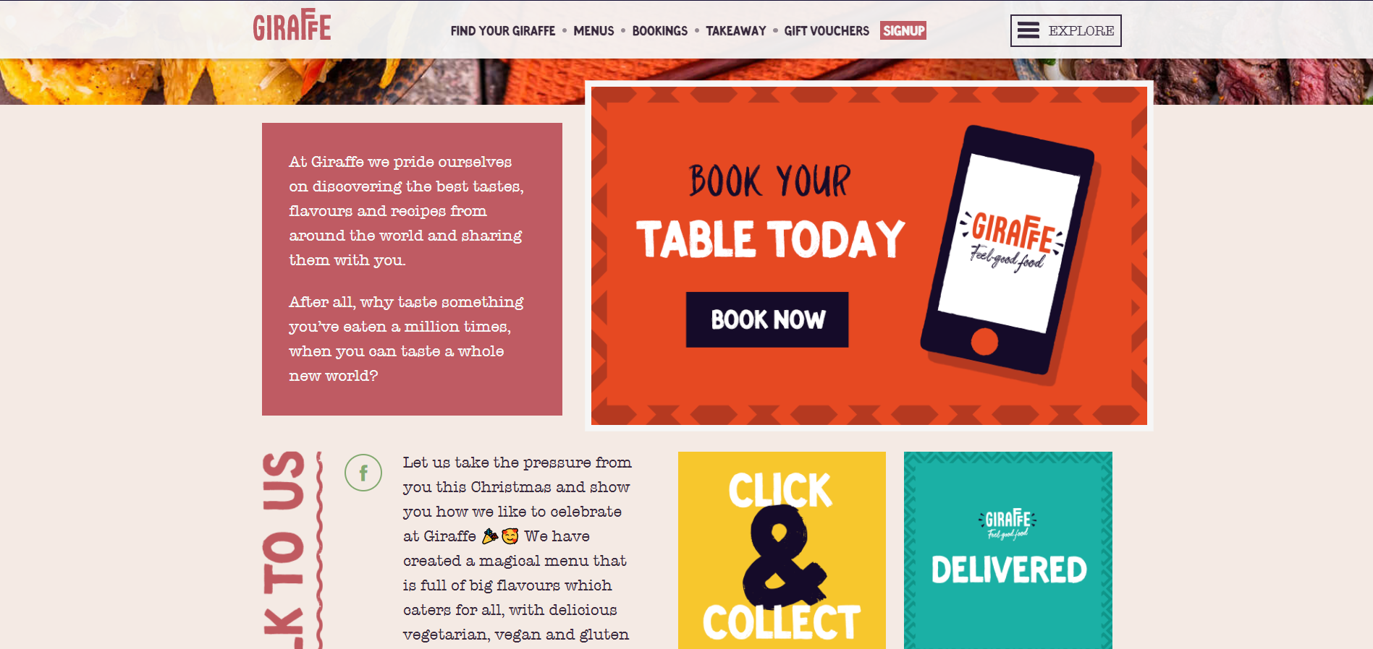

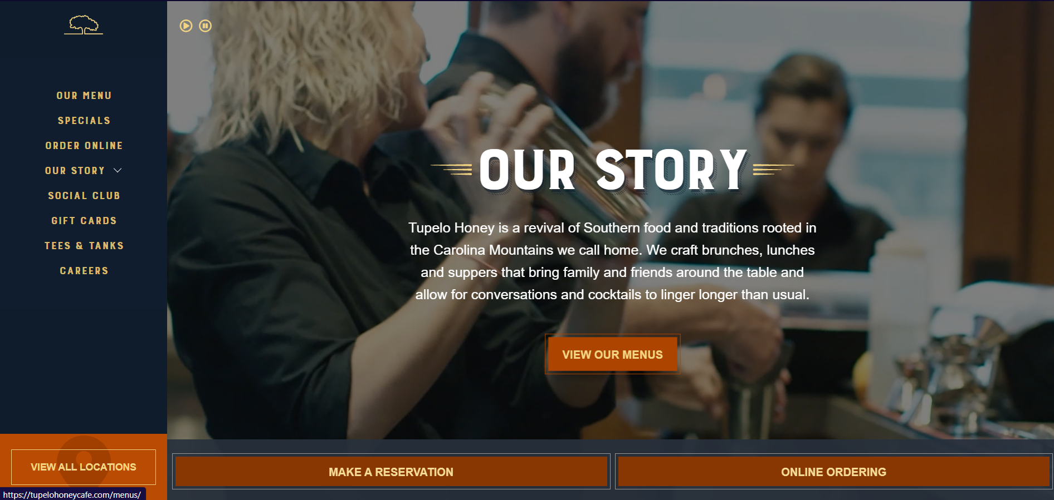

**System Requirements**

**Hardware Interface:**

• Pentium Processor

• 60 MB of free hard-drive space

• 128 MB of RAM

**Software Interface:**

• Operating System: Windows (Vista/7 or above)

• Web Browser: IE 10 or above, Mozilla FF 31 or Google Chrome

• Drivers: Java Runtime Environment

• Integrated Development Environment: Eclipse J2EE or Apache Tomcat

**References**

* <https://www.giraffe.net/>
* <https://www.arethusaaltavolo.com/>
* <https://tupelohoneycafe.com/>